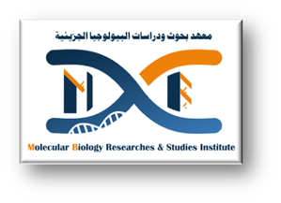



**Gehad Mohammed Abd-Elnaiem**

**Personal information**

**Email** Gehad.Mohammed@aun.edu.eg

**Mobile number 00201027642745**

**Academic education**

**2017 – 2022** B. Sc of Veterinary Medicine, Faculty of Veterinary Medicine ,Assiut University.

**Academic positions**

**15/3/2023 – now** Demonstrator at Molecular Biology Department, Molecular Biology Researches & Studies

Institute, Assiut University, Assiut, Egypt**.**

**Language skills**

Arabic native language

English good knowledge

**Workshops**

23-25 october2023 cell and tissue culture techniques and applications.

5-6 December mesenchymal stem cells (MSCS) isolations and characterization.

12 December basics of flow cytometry for beginners.

25 February-20may scientific basis for preparing and writing scientific research.

**Conferences**

8th-9th May 2023 1st conference of applied molecular biology.

14th May 2023 1st scientific forum environmentally friendly projects.

**Researcher information**

**Official website:**

[https://www.aun.edu.eg/molecular_biology_institute/ar/gehad-mohammed-abd-elnaiem](%20https:/www.aun.edu.eg/molecular_biology_institute/ar/gehad-mohammed-abd-elnaiem)

**Google Scholar website:**

<https://scholar.google.com/citations?user=GiyRNnkAAAAJ&hl=en&fbclid=>